Background:

*Provide the required screenshots with your account ID in them to get full credit for this exercise and respond to the short answer writing prompt. (20pts)

Problem #1 (5pts):

**In this exercise, you will create a managed relational database with RDS**

#### Creating an RDS Instance

In this section you will create a managed database.

1. Open a browser and navigate to the RDS dashboard.

The dashboard shows all the RDS related resources that you currently have created.

1. In the left navigation pane, select Databases.
2. Click Create database. All parameters and settings are configured in a single page.

**Figure 1.**

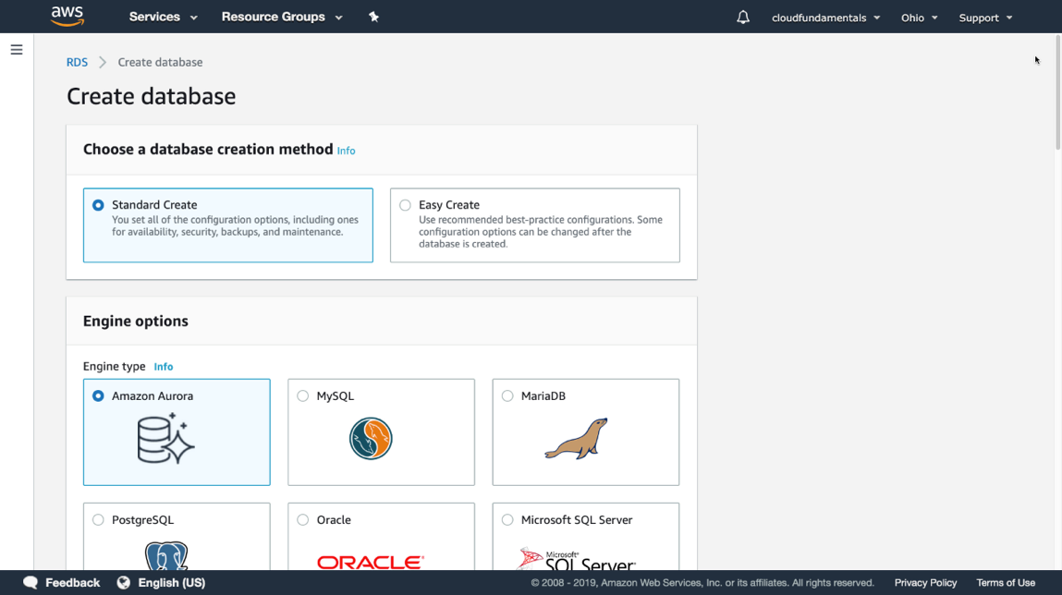

1. There are two creation options:
   * Standard create, where you set all configuration options
   * Easy create, which uses best-practice recommended settings

Select Standard Create.

1. Specify the engine type under Options. Select MySQL not Aurora
2. Choose the template that you want to use.

Select Free Tier

1. The next option is the DB instance identifier, which is the unique name of your instance across all regions for your account.

Type **database-cldr**.

1. Provide the master username and password for this instance. Use **admin** as username and select Auto generate a password.
2. The next option specifies the size of your database instance. Because you selected (Burstable including T classes) the Dev/Tst template, there is a smaller number of available options.

Select db.t2.micro.

1. In the Storage section, indicate how much space you want to allocate to the database. It is possible to start with a smaller size and allow to autoscale, indicating a maximum amount of storage that can be used.

Leave the default settings.

1. For Multi-AZ deployment [Not included in Free Tier]
2. Connectivity determines in which VPC this database instance will be launched. You can specify if you want this database to be publicly accessible and secured with a security group.

Select the VPC that you created in a previous exercise. The VPC cannot be changed after the instance has been launched.

1. Next, you specify if you want authentication to be done only via password or if you want to provide access to IAM users and roles.

Leave as Password authentication only.

1. Click Create database and wait for your instance to start. This process takes several minutes. Continue with the next exercise and come back once the database is running.
2. Disable Enhanced Monitoring
3. Select your running instance and familiarize yourself with the managed database console.

**Figure 2.**

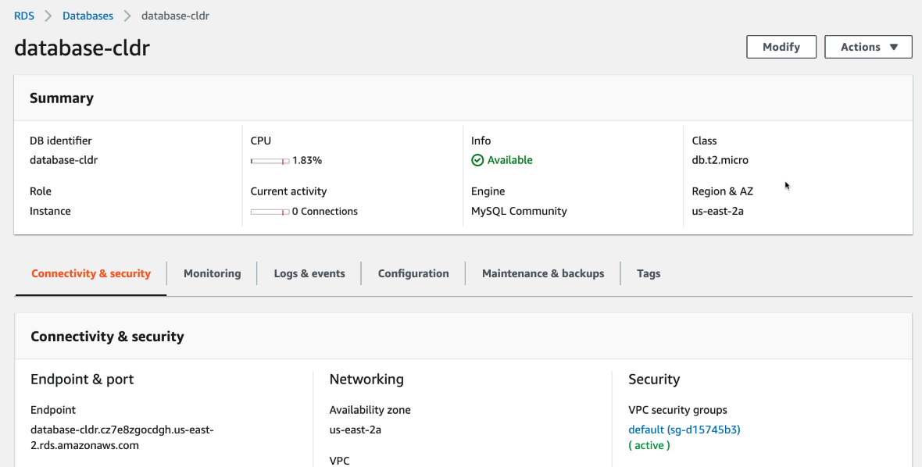

*Action: Please include a screenshot of these database details with your AWS account ID to receive credit  
  
*Delete your running RDS Instance after you completed the steps

#### Problem #2: Creating a DynamoDB Table (5pts)

In this section you will create a DynamoDB (NoSQL) table.

1. Open a browser and navigate to the DynamoDB dashboard.
2. In the dashboard, click on Create table.
3. DynamoDB is a NoSQL store; it does not require a schema. Only the table name and primary key are required. Optionally, you can provide a sort key. Use the following information:
   * Enter **s3-dynamo** as table name.
   * Enter **parent** as the partion key, of type String.
   * Check Add sort key and enter **child**, of type String.
4. Leave Use default settings checked.
5. Click Create and your table will be available shortly.
6. Inspect the tabs available for your table.

*Action: Take a screenshot of your new table in the Dynamo DB Table

**Problem #3 Create Items in Dynamo DB table (5pts)**

In the navigation pane on the left side, select **Tables**. Choose the table name for use as the destination, and then select the **Items** tab.

Select **Create Item**. The Create Item screen provides an interface for entering the required attribute values. Any secondary indices must also be entered.

After entering all essential information, select **Save** to add the item.

*Action: Please the table items view and an item in it with you AWS account ID in the corner to get credit

Delete the table after your screenshot

You have successfully created items and deleted a DynamoDB table.

Problem #4 (5pts):

*Action: Describe in 2-4 paragraphs (roughly 8 sentences) what advantages does RDS provide vs. running a database on a standalone Ec2 instance? Please cite your sources and remember to follow the university’s academic integrity policies.